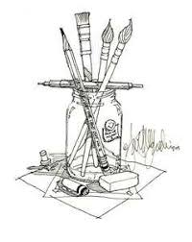**The Brush Invention Challenge**

Studying makeup artistry is a very varied, exciting and colourful journey.

Makeup looks may be inspired by history, the world around us, current trends, art movements, infact, almost anything!

If we are working with best practise and following health and safety, there is a lot of scope for us to be inventors within our trade– developing new trends, techniques and sometimes even inventing new tools.

It might be that using a certain sponge gives us a certain texture or effect, or using a certain object gives us a shape to use as a stencil.

**With that in mind, this task is all about you being the inventor.**

We all use makeup brushes in different ways depending

on the look we are trying to achieve.

**If you could design your own dream brush -**

What would it look like?  
  
Would the handle be made of any specific material?

Would you choose tapered bristles? glittery bristles?

What would you call it?

**Your challenge is to submit an annotated sketch or model of your brush invention and a justification of your decisions to submit to the factory for prototypes to be made for you. HAVE FUN INVENTING!**

