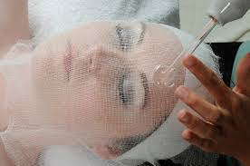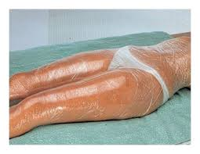**Beauty Therapy**

**Welcome Taster Activity**

**Scenario:**

Your task is to produce an information sheet in which you must **research and describe three treatments from the list below.**

* Artificial nail services
* Electrical Facials
* Epilation treatments
* 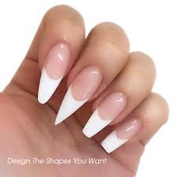Body massage
* Body massage using pre-blended oils
* Heat and water therapy
* Hot stone therapy
* Indian head massage
* Electrical body treatments
* Body wrapping
* Self-tanning treatments

**How can I find the information?**

Using a range of research; from websites, salon pricelists, spa pricelists, brochures, magazines, you tube etc.

**How to present your work:**

Your work can be typed, hand written, include images, , be creative.

