

**Software and Web app development – Preparation work for my course**

**What skills should I familiarise myself with or should I research into over the summer?**

* Keep up to date with key computing news by watching the News, documentaries and reading computing articles and magazines on computing, programming and new technologies and its effect on industries.
* Use websites such as code academy, Gdevelop to develop your programing skills and apply your new techniques to your own projects.
* Autodidactic learning - Follow online video tutorials to develop new skills for programing, and familiarise yourself with software and code that you may use on your course

**Complete the following tasks over the summer:**

Introduction

It is important to understand that programing is an industry in its own right, which is utilised in many forms. As a new software and web app development student, the most obvious application is designing and creating basic working products but as you will find out, there are many more applications of programing which you will need to research and document.

Once you have gained a solid foundational understanding of the theory and application of programming you will need to learn some programing package so that you can start developing the skills, techniques and shortcuts to be able to develop your own ideas into tangible working projects.

The world of programming is mammoth, it is a highly technical and creative world full of new concepts with cutting edge software being updated every day. There is no better time to start learning!

**Please see tasks to complete on the following pages**

**Tasks to complete:**

**Task 1 – Create a game!**

GDevelop is an online game creator tool.

1. Visit GDevelop here, <https://gdevelop-app.com/>, you can use the online creation tools, you do not have to download anything. Click on Try It Online.

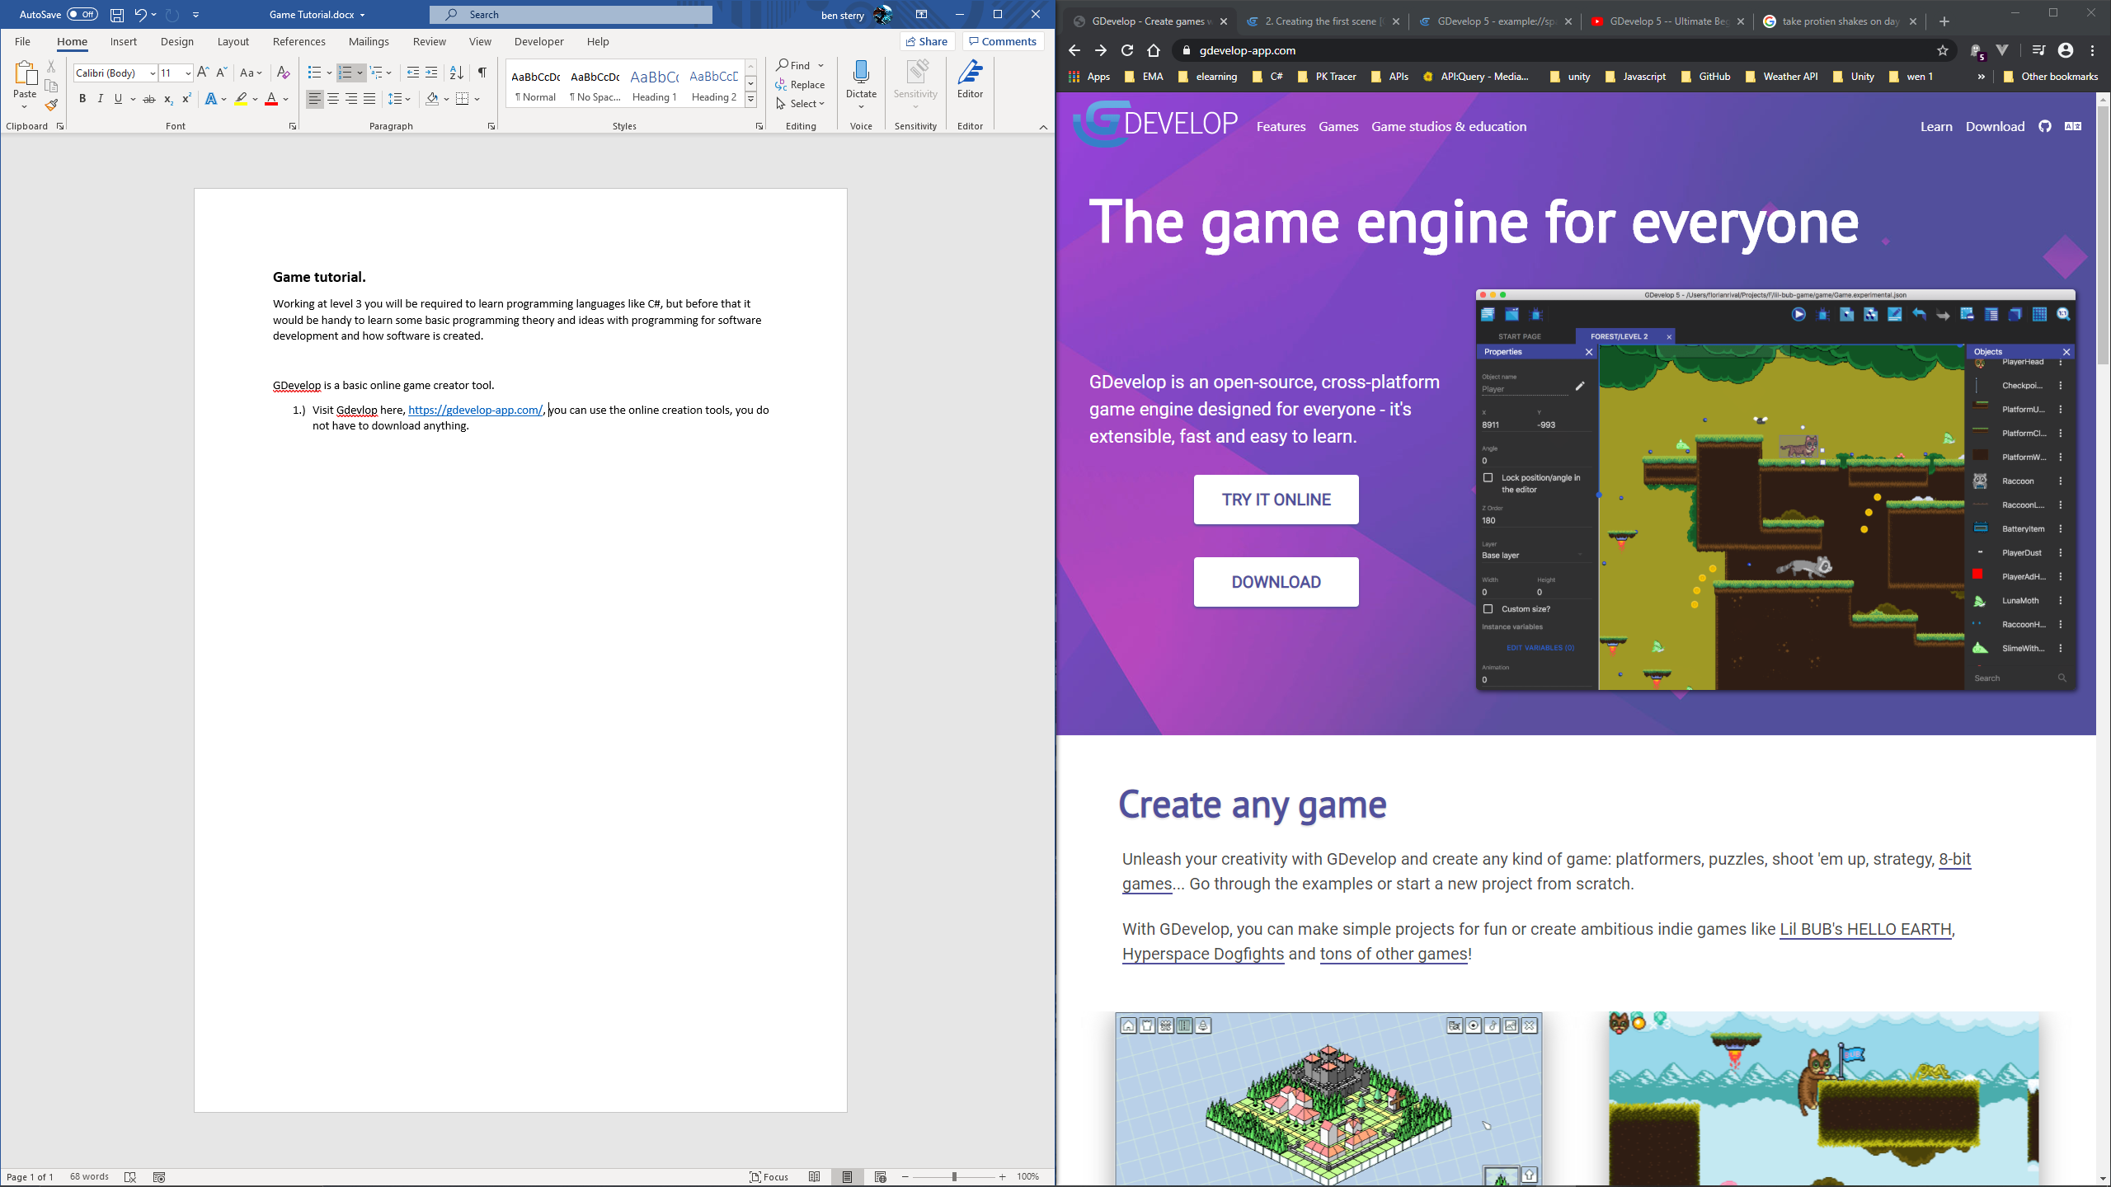

1. You will see this page next, you can choose to download the app if you wish or you can click close and continue online.

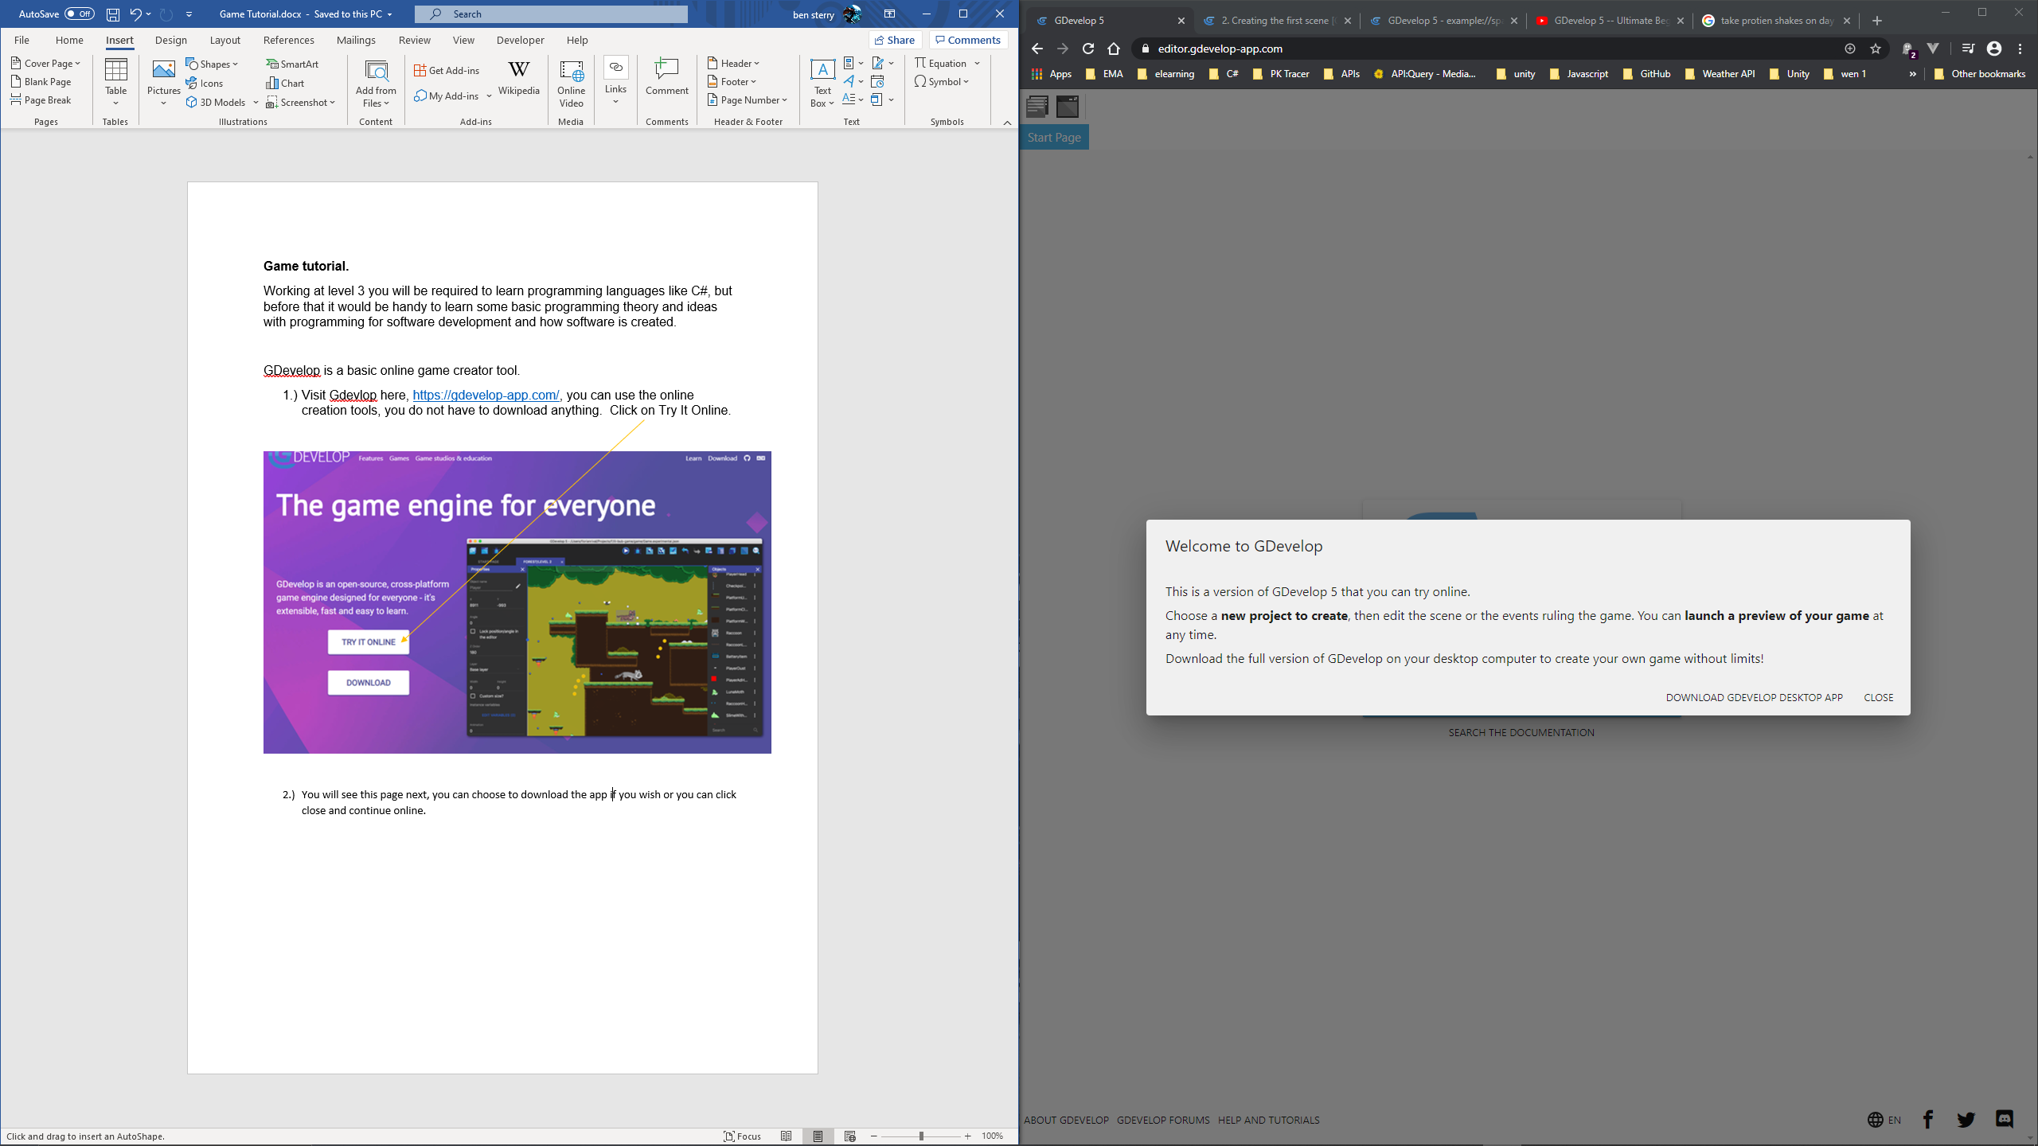

1. Next you will see this screen and you need to click on “Create a new Project”.

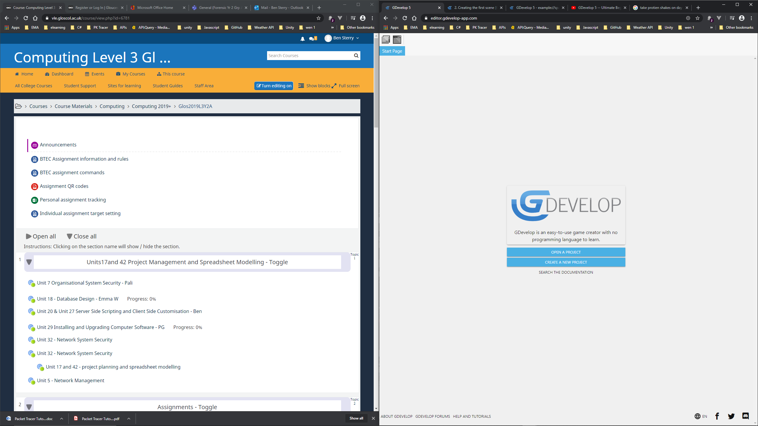

1. Then click on the tutorial tab.

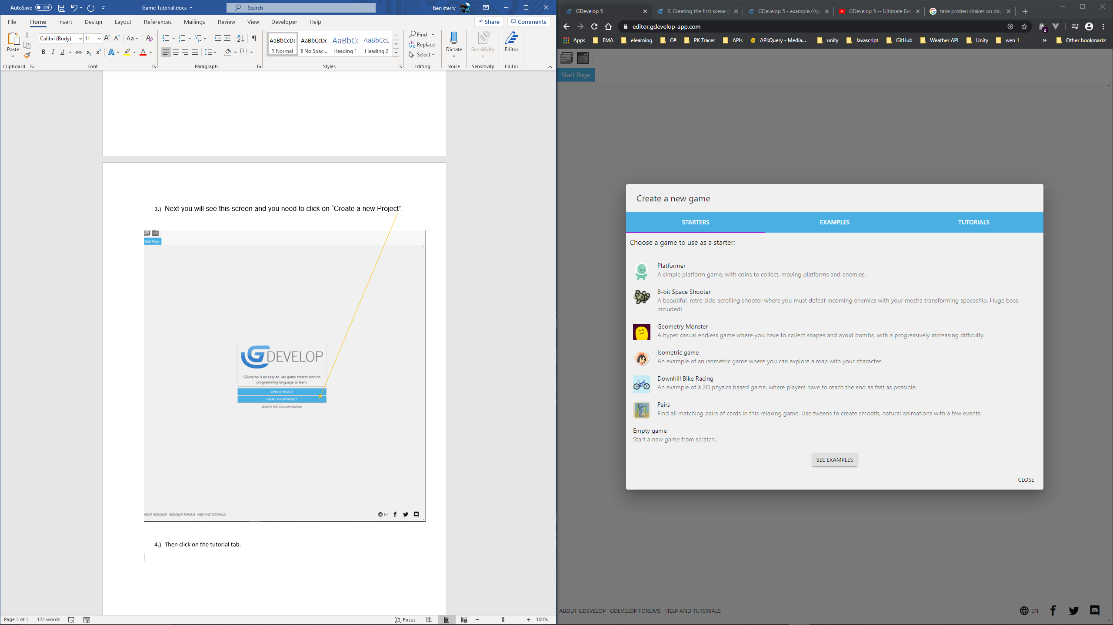

1. Click on one of the tutorials and work your way through all the different steps.

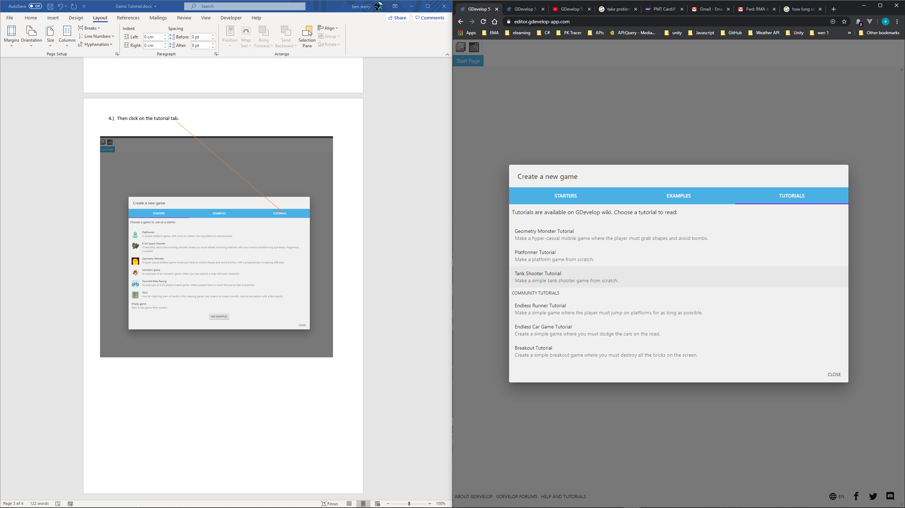

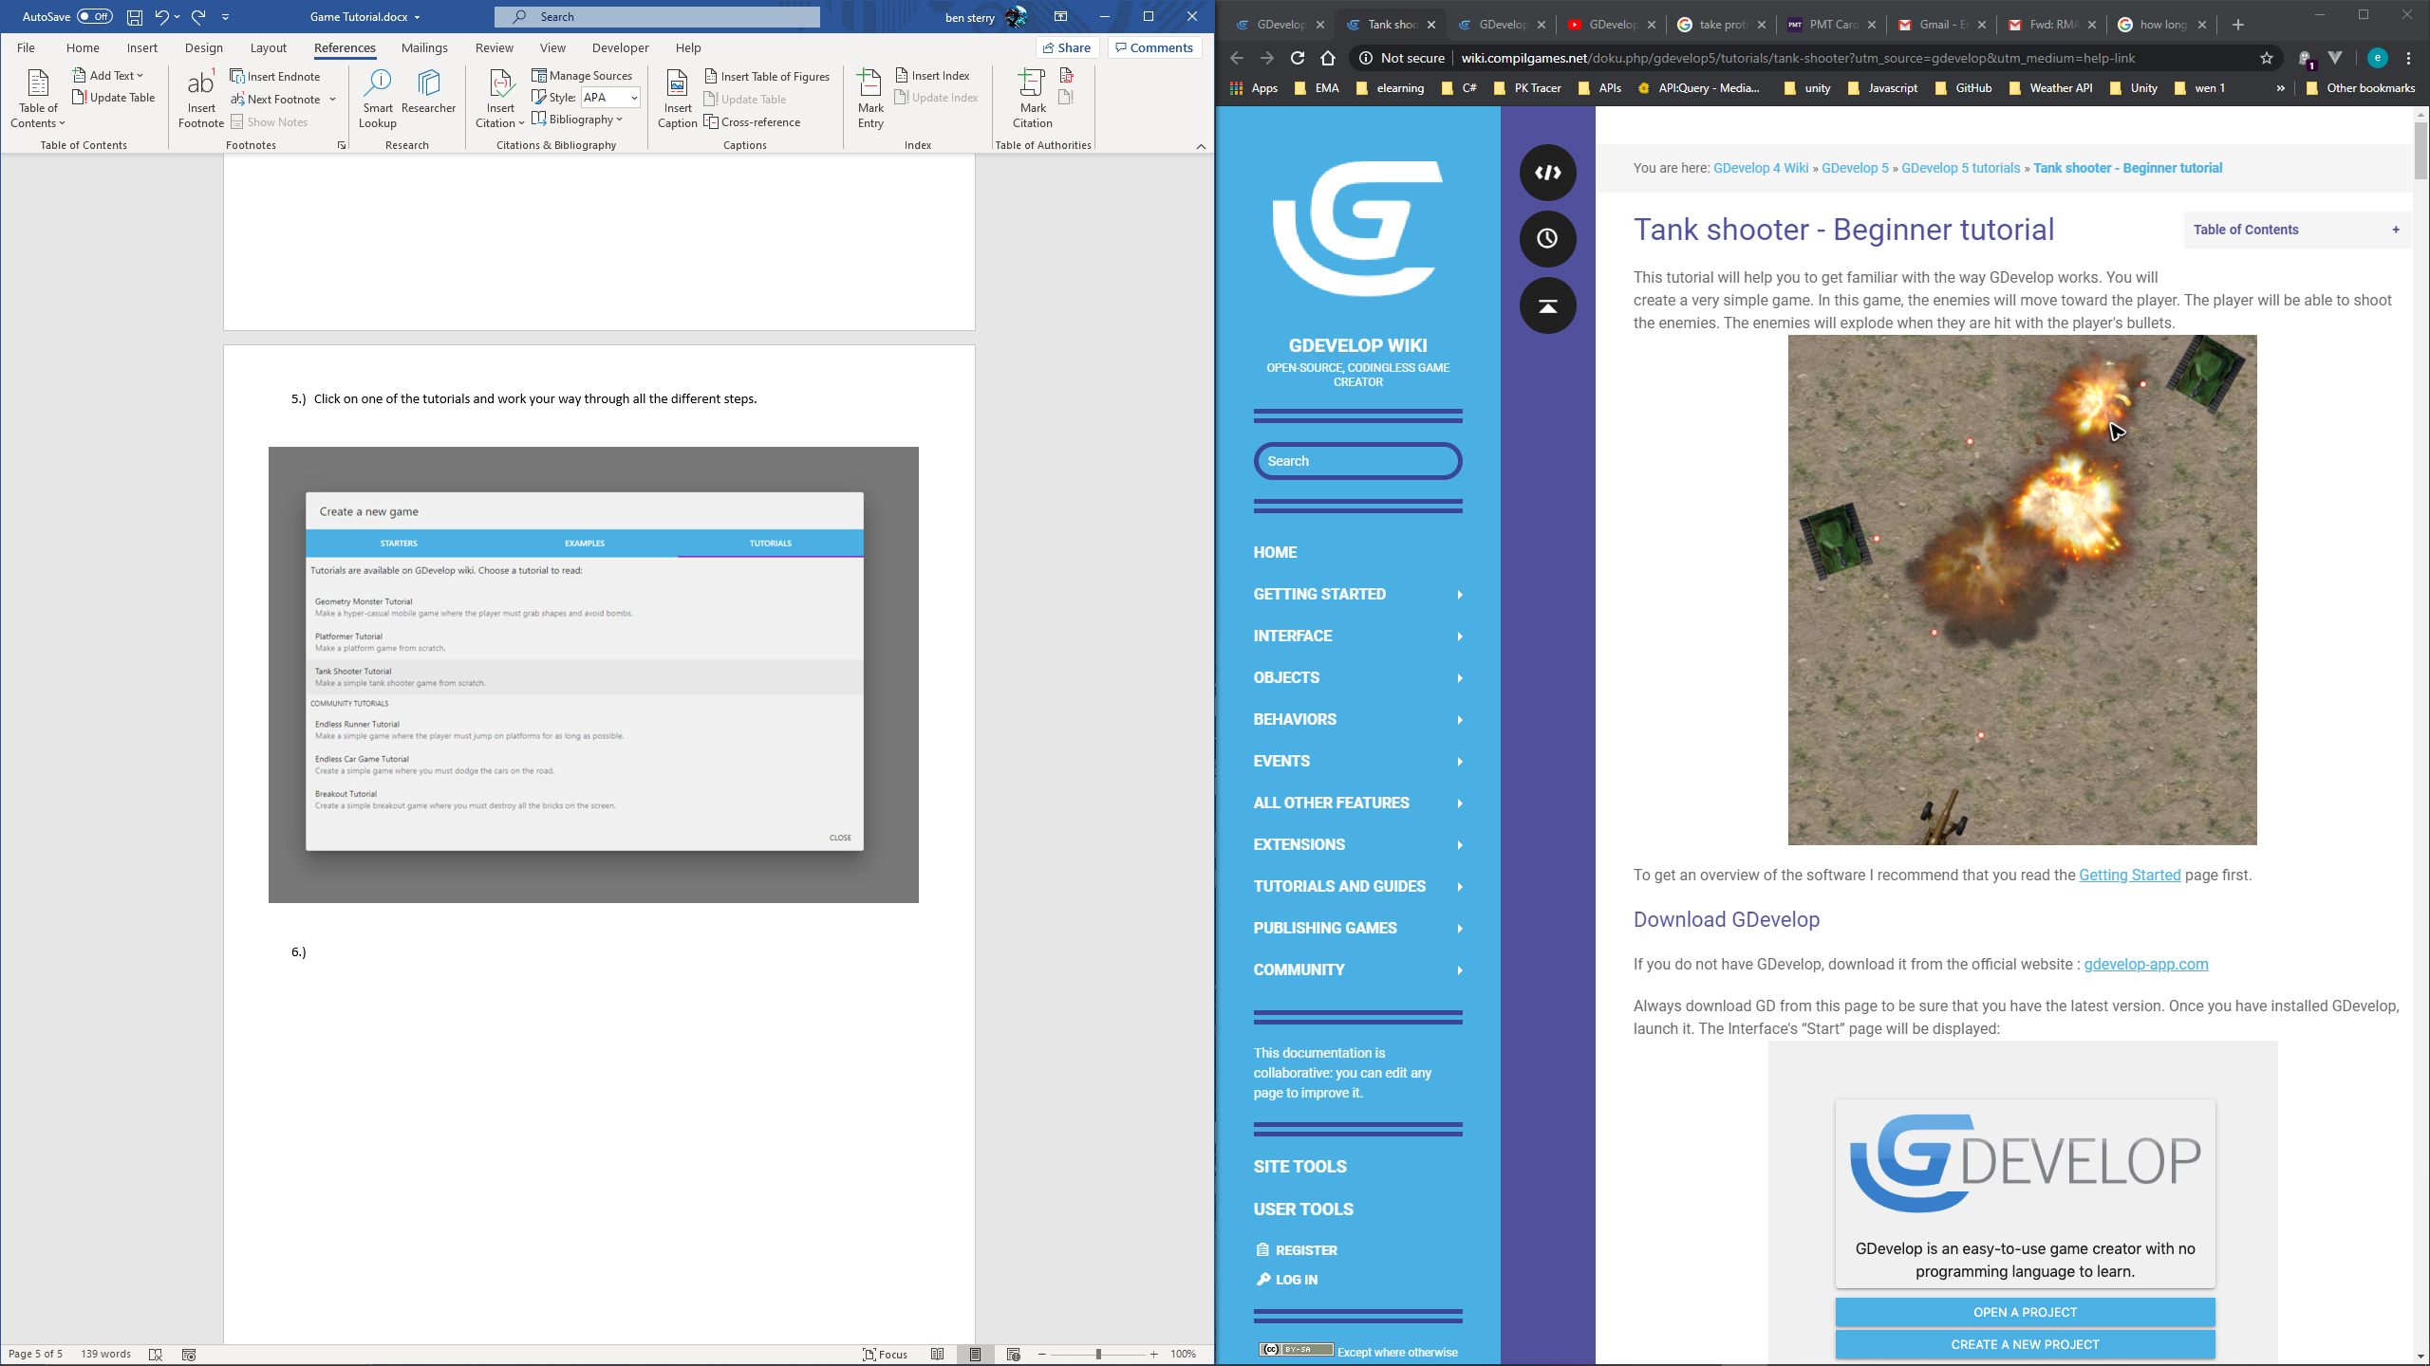

**Task 2 – Research and review:**

When you have completed your game, have ago at answering the following questions.

In programming.

1. What is a variable? What does it do?
2. What do you think “Random” is? What is it used for?
3. What is an object?

Then write a review on the product that you have completed, include what went well, what constraints you faced and how your product would work in industry.

**When you have completed both tasks email them to** [**ben.sterry@gloscol.ac.uk**](mailto:ben.sterry@gloscol.ac.uk)

**What websites will help me?**

**YouTube**

**Google**

**GDevelop**

**Code.org**

W3schools

**WHAT WILL I STUDY IN MY FIRST YEAR**

• **Website development**

**• Mobile app development**

**• Software testing**

**• Computer games development**

**• IT project management**

**TOPICS INCLUDE**

• **Project planning**

**• Social media in business**

**• Programming languages**

**• Information technology systems**