**Scenario:**

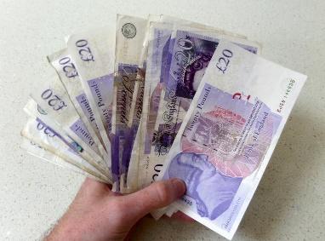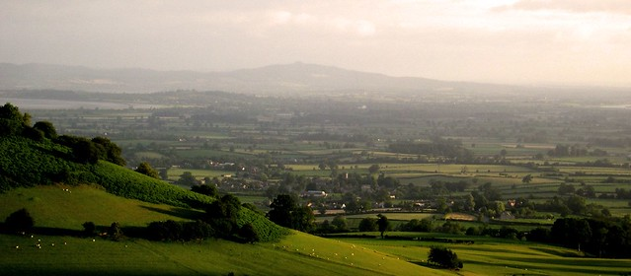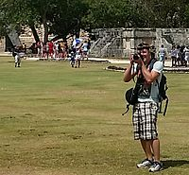

You have been given £10,000 from a lottery win to start a small business. The conditions of this money is that you start a business within the travel and tourism industry and that it is located within Gloucestershire. Although £10,000 will go a long way to funding the business you may also decide to investigate a loan.

**Task 1:**

You are required to produce a **feasible** business case for your travel and tourism business enterprise. You must determine the overall finances needed for the enterprise and then keep within those constraints in your planning.

Your business case must be thoroughly researched and include:

>Clear objectives

>How you are filling a gap in the market

>How you will gain competitive advantage

>Cash flow forecast and financial details

>Details of intended marketing materials

>Clear timescale for set up

>Operation of the enterprise

We would recommend you planning a very small and uncomplicated venture. Look around the area as to what is already available and also look for ideas in other parts of the UK or even the World that you might be able to take inspiration from.

**Task 2:**

You will present your business case to a representative of The Princes Trust. It is worth investigating their very helpful website <https://www.princes-trust.org.uk> .

Be prepared to make an **oral presentation** supported by a **professional** written submission. Expect to **answer questions** on your proposal. This could be in the style of the pitches on BBC Dragon’s Den programme. There are lots of clips you can view to get inspiration on <https://www.youtube.com>

**What to produce:**

1. A business case written as a report

2. An oral presentation of your business case