**Why are codes important?**

**It’s all about data transmission that uses in**

**TV, internet, mobile phones and games**

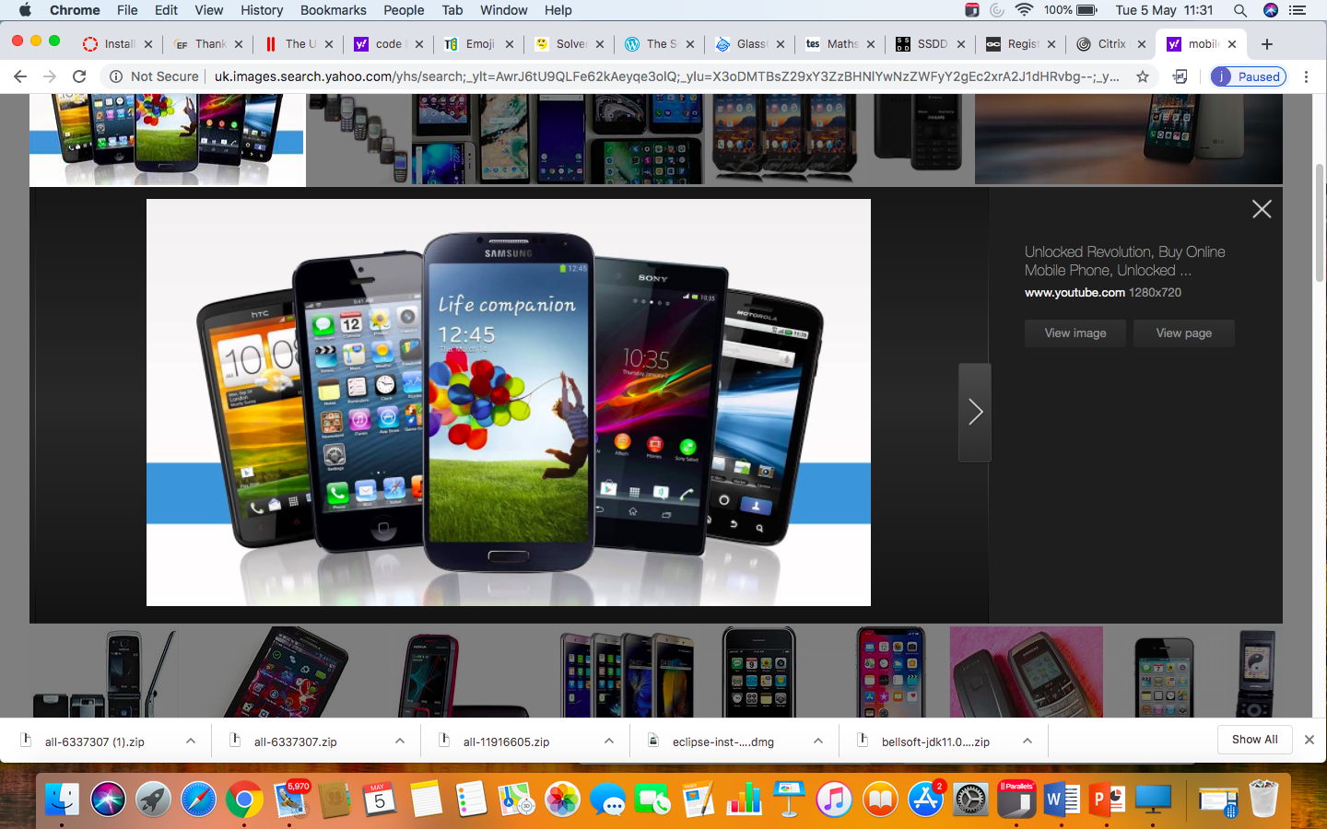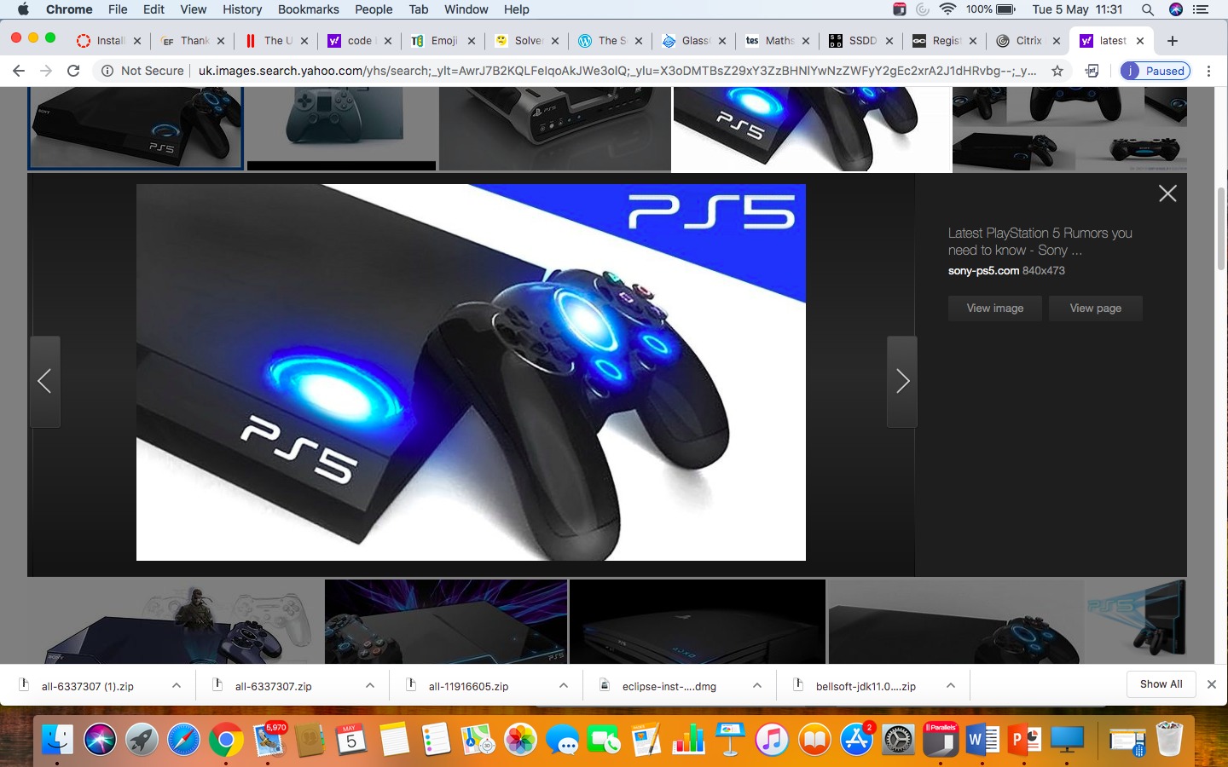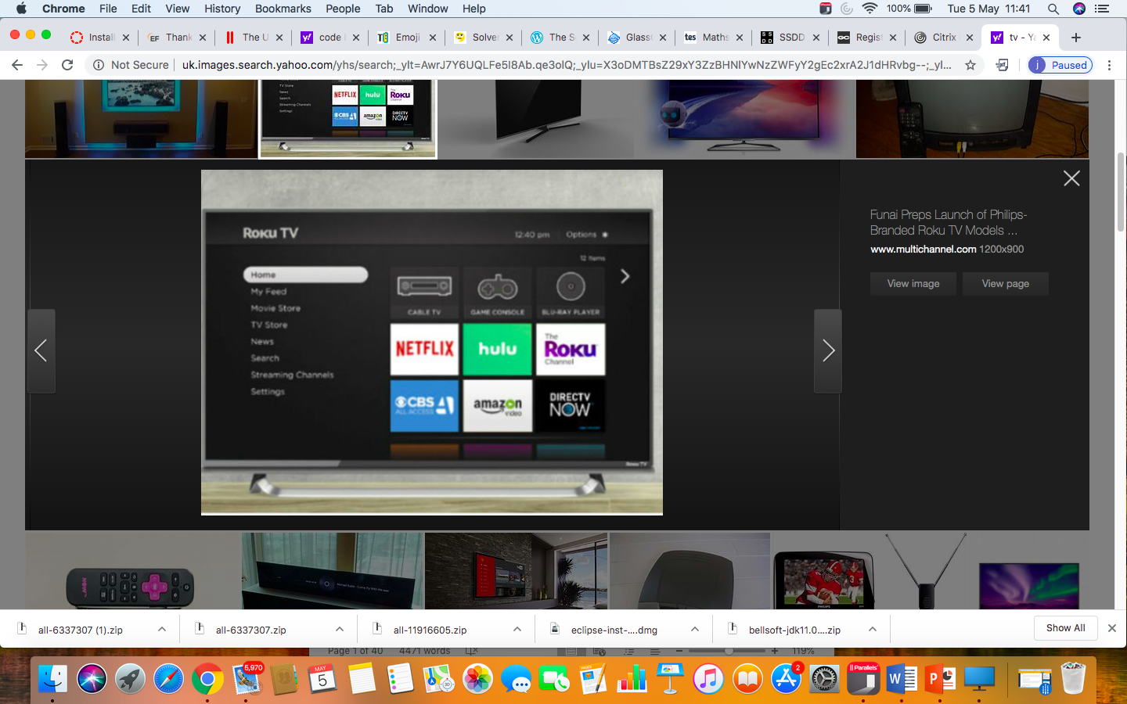

**So enjoy cracking puzzles and codes !**

1. **Using emojis, find the answers;**

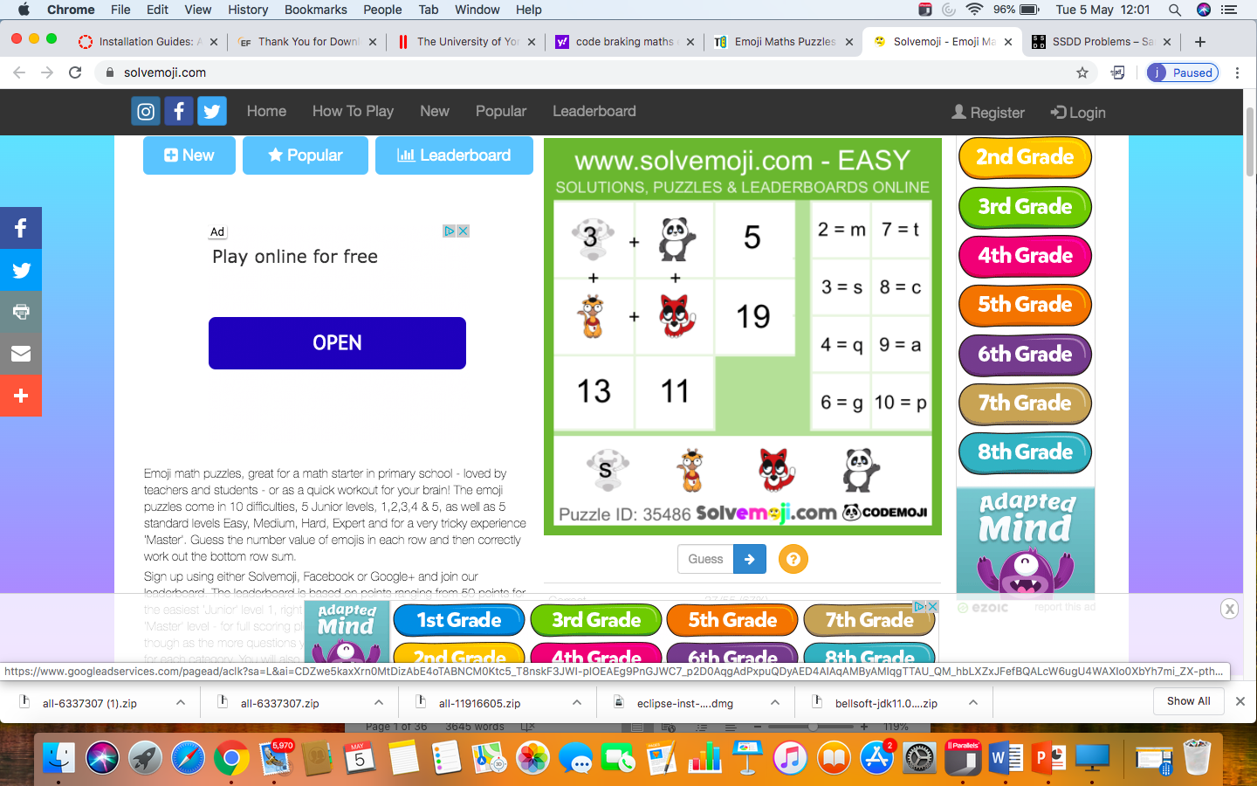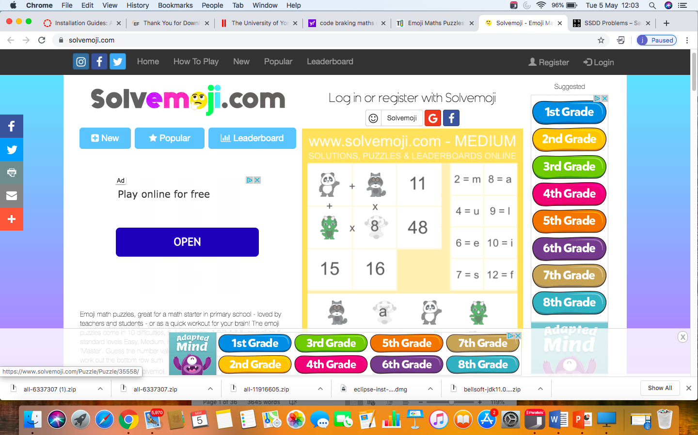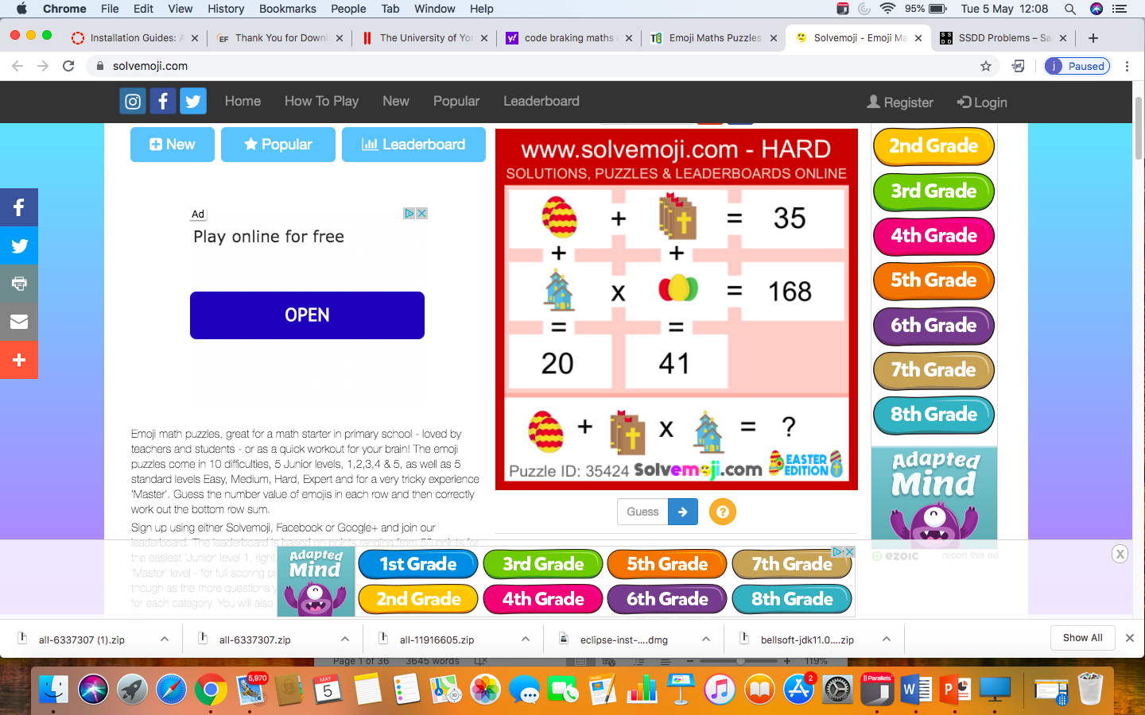

_ _ _ _ _ _ _ _ ____

1. **Enrich number puzzle**

There are 6 different numbers written in 5 different scripts. Can you find out which is which?

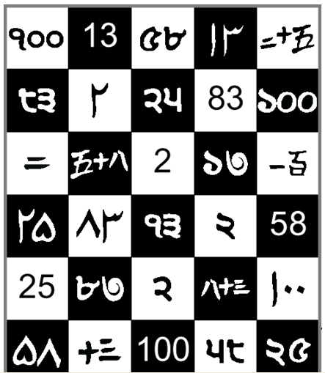

Answers :

|  |  |  |  |  |  |
| --- | --- | --- | --- | --- | --- |
|  | Script 1 | Script 2 | Script 3 | Script 4 | Script 5 |
| 1st number |  |  |  |  |  |
| 2 |  |  |  |  |  |
| 3 |  |  |  |  |  |
| 4 |  |  |  |  |  |
| 5 |  |  |  |  |  |
| 6 |  |  |  |  |  |

1. **ISBN CODES**

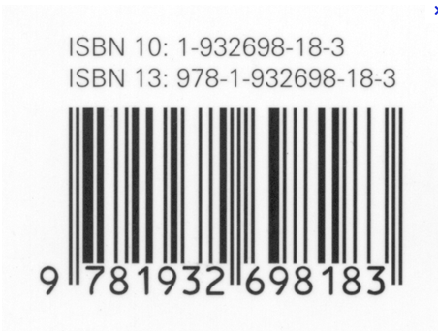

This is an ISBN code is used on all books. The first numbers tell you which country published it, the next the identity of the publisher, then the book reference.

**Here is how it works (** branch of coding method : Error detection and Error correction)

Look at the **10 digit** ISBN number. 1-932698-18-3

1. The first digit is 1 - 1x1 = 1
2. The second digit is 9 - 2x9 = 18
3. The third digit is 3 - 3x3 = 9

………..

10. We do this all the way until 10x3 = 30

11. We then add all the totals together which will be 286

12. Divide this final number by 11 which will be 286 /11= 26.

This means a genuine barcode

**Try whether the following are ISBNs**

1) 0-13165332-6

2) 0-1392-4191-4

3) 07-028761-4

**Challenge (hard!) :**

The following ISBN code has a number missing, what is it?

1. 0-13-1?9139-9
2. **Can you solve the puzzle to find the hidden sentence?**

**For the puzzle use**

**X = 2**

**Y=3**

**Z= -1**

First generate some numbers by substituting the above values into the expressions below. Then convert those numbers into letters using the alphabet converter.

First word: 7y + x, 2y + x, -z, 2(4y+2z)

Second: 5x+z, -y+11x

Third: 7y+z, 4x, 2y+z

Fourth: Y2+3z, y2, x2 +y2 + x + y, (z)2 + x4 +x, 7y + z

Fifth: 2x3+y, 2y2+z, 7y, -z, (y+x)2 + 7z, (x+y)

Sixth: (y+z)4 + 2z, 7y, -13z, -2z, x+y, 2y2

Convert your numbers into a hidden message, using the alphabet

A=1, B=2, C=3, D=4, E=5, F=6, G=7, H=8, I=9, J=10, K=11, L=12, M=13, N=14, O=15, P=16, Q=17, R=18, S=19, T=20, U=21, V=22, W=23, X=24, Y=25, Z=26

What is the hidden message? And what is the answer?

1. **CREDIT CARD CODES**

Credit cards use a different algorithm – but one based on the same principle – that if someone enters a digit incorrectly the computer can immediately know that this credit card does not exist.  This is obviously very important to prevent bank errors.

[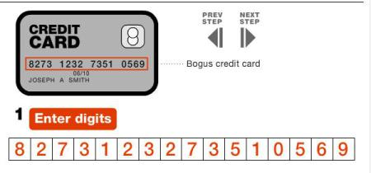](http://1millionmonkeystyping.files.wordpress.com/2013/05/creditcard2.jpg) long 16 numbers

[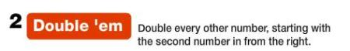](http://1millionmonkeystyping.files.wordpress.com/2013/05/credit-card-4.jpg)

[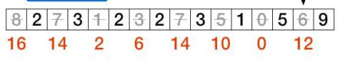](http://1millionmonkeystyping.files.wordpress.com/2013/05/creditcard3.jpg)

[credit card 6](http://1millionmonkeystyping.files.wordpress.com/2013/05/credit-card-6.jpg)

[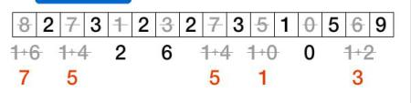](http://1millionmonkeystyping.files.wordpress.com/2013/05/credit-card-5.jpg)

[credit card 8](http://1millionmonkeystyping.files.wordpress.com/2013/05/credit-card-8.jpg)

[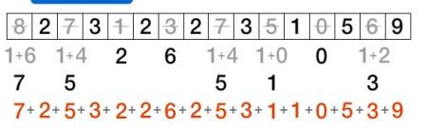](http://1millionmonkeystyping.files.wordpress.com/2013/05/credit-card-71.jpg)

[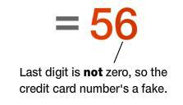](http://1millionmonkeystyping.files.wordpress.com/2013/05/credi-card-9.jpg)

Try and use this algorithm to check which of the following 3 numbers are genuine credit cards:

1) 5184 8204 5526 6425

2) 5184 8204 5526 6427

3) 5184 8204 5526 6424

Solutions

1. Emojis Easy : SPAM

Medium : MALE

Hard : 412

1. Enrich number puzzle

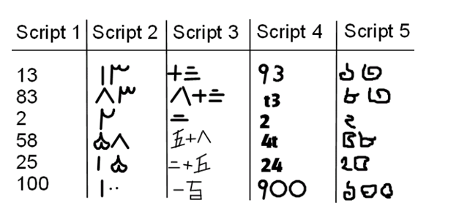

1. ISBN codes
2. Yes
3. No
4. No
5. 3 – using x as the missing number we end up with 5x + 7 = 0 mod 11. So 5x = 4 mod 11. When x = 3 this is solved.
6. Hidden message and answer

Message : What is the first square number?

Answer : 1

1. Solution to Credit card

The second one is genuine