

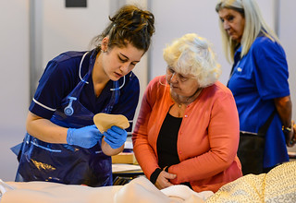

**Health and Social Care**

We look forward to welcoming you to Health and Social Care as a student with us at Gloucestershire College in the next academic year.

In preparation for your course you should complete the following tasks which give you opportunities to research and complete activities that help you think about and apply concepts that are directly relevant to the course.

**Task 1**

1. Explain why you want to work in Health and Social Care.
2. What do you think it will involve and why are you interested in a career in this sector?

Use creative ways to demonstrate your thoughts and enthusiasm for this choice of course.

**Task 2**

1. Please read the Nursing and Midwifery Council information. (access using links below ) <https://www.nmc.org.uk/standards/code/>

[http://www.staff.city.ac.uk/m.j.jones/PDFs/Guidance-on-professional-conduct-for-nursing- and-midwifery-students-September-2010.pdf](http://www.staff.city.ac.uk/m.j.jones/PDFs/Guidance-on-professional-conduct-for-nursing-%20%20%20%20%20%20%20%20and-midwifery-students-September-2010.pdf)

1. Identify the four core principles of the NMC code of Practice
2. For each of the four core principles, identify 2 requirements that are expected of a nurse/midwife and give an example of how the professional would demonstrate it in practice (you should then have 8 examples in total)

**Task 3**

1. Please research **The Care Certificate** documents using the link below

<https://www.skillsforhealth.org.uk/standards/item/216-the-care-certificate>

1. Read the Care Certificate Introduction and the Glossary
2. Access the following workbooks, read the information and complete the written task identified

* **Standard 4** - Equality and Diversity - write your response to the reflective task (page 7) and complete activity 4.1a (page 9)
* **Standard 6** – Communication - complete activity 6.1a (page 10)
* **Standard 7** - Privacy and dignity - complete activity 7.1b (page 8)

**Notes for completion**

* Write your answers on a Microsoft word document or other suitable electronic format
* Put your name and student number in the header or footer
* Label your answers for each task
* Check your spelling and grammar for clarity and accuracy

