

|  |
| --- |
| **Computing Cyber Security – Preparation work for my course** |

**What skills should I familiarise myself with or should I research into over the summer in preparation for my course?**

|  |
| --- |
| * Keep up to date with key computing news by watching the News and reading computing articles and magazines. * Watch documentaries on the television on Computing, cyber security forensics and new technologies * Use websites such as code academy, immersive labs, asecurity |

**Complete the following tasks:**

|  |
| --- |
| You work for Hosting Ltd as a trainee network technician. You have been tasked to create a presentation, an information sheet and handout for the Senior Management Team. All documents should be clear, concise and include a bibliography.  **Task 1**   1. Create a presentation describing the types of network attacks possible. 2. On the same presentation, you will need to add a section which describes how networked systems can be protected using a layered security model. 3. On the same presentation you need to add a section that suggests how users can be authenticated to gain access to a networked system.   **Task 2**  Organisations face an increasing number of challenges in defending against security breaches. Create an information sheet that explains the measures organisations can take to defend themselves and think about “Intrusion Protection\Prevention System” and “Intrusion Detection Systems” – how are they different? Describe the operation of an IPS & IDS providing a description of the two systems, explaining how each system works and the actions the respective systems take.  **Task 3**  You need to create a report that provides an in-depth analysis of two recent security threats, which are no more than 24 months old. Discuss the type of attack, its eventual outcome and the impact on any company or individual involved.  **Task 4**  Using the tutorial below create a secure, virual computer network. |

We can build Computer Networks Virtually to test the functionality and identify any security threats. Download the packet tracer software here: <https://www.netacad.com/courses/packet-tracer> and use the following tutorial to create a virtual network.

Packet Tracer Tutorial

1.) Open packet tracer click on the end devices tab. Drag and drop a server and 2 PCs into the window.

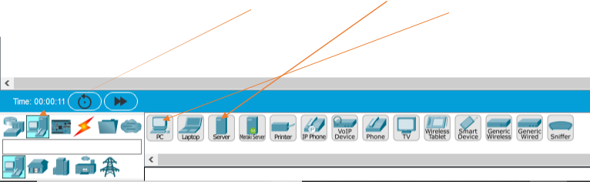

2.) Your screen should look like this.

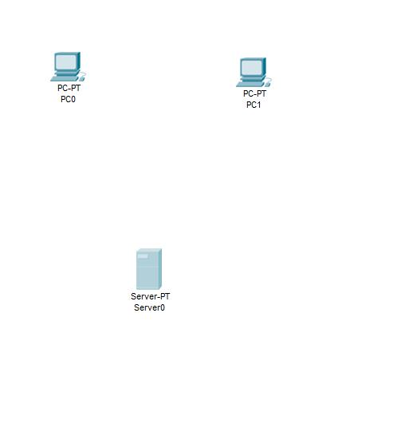

Click on the Network devices tab and drag and drop a switch into the window.

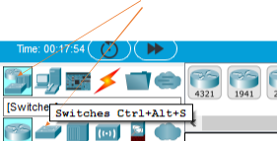

Your screen should look like this.

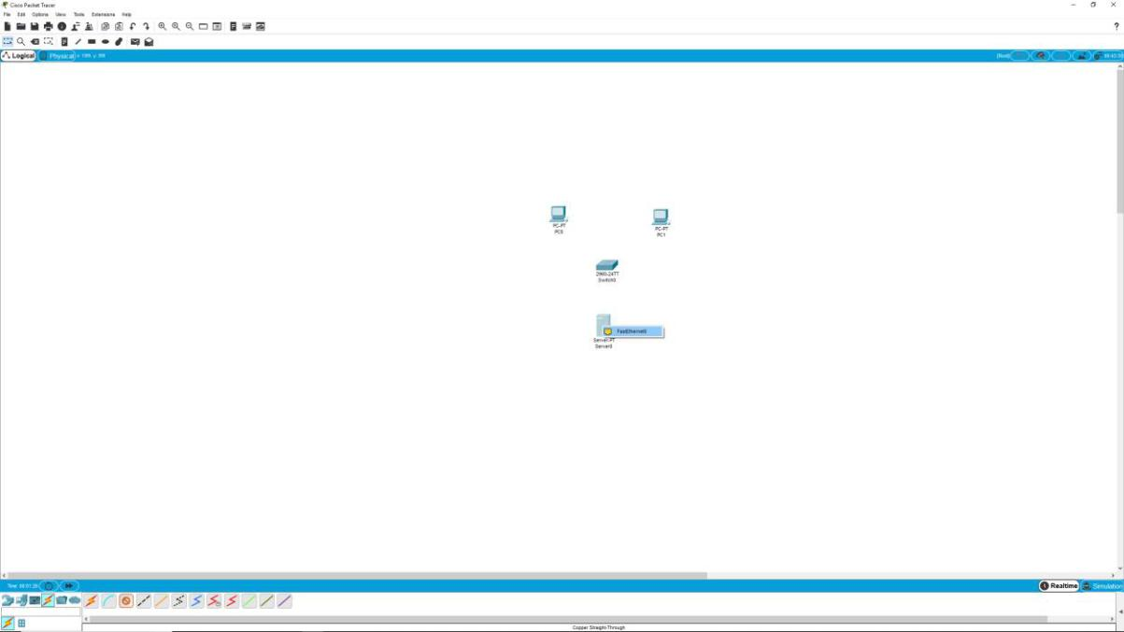

3.) Now click on the cable icon and select the copper-straight through connection.

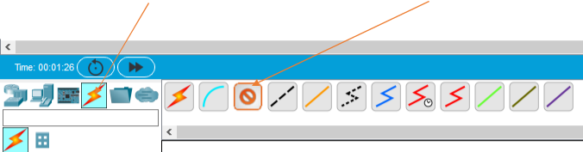

4.) Now click on the server and connect the server to the switch like

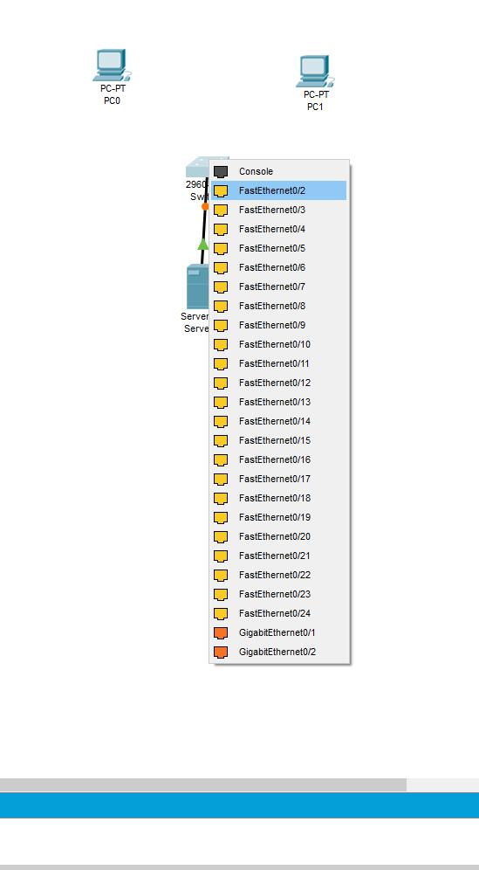

5.) Your network should look like this.

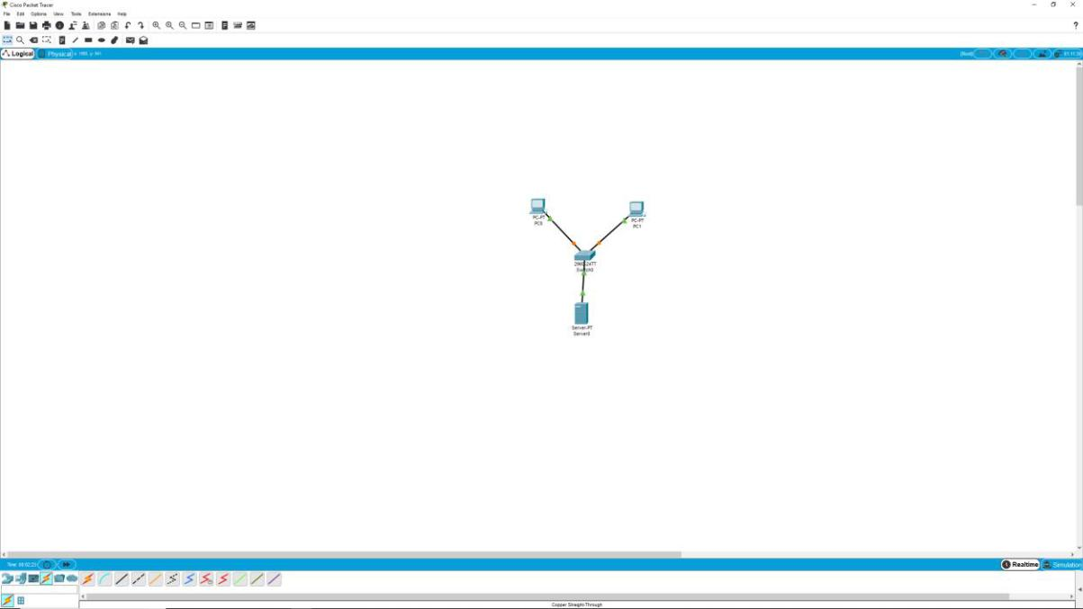

6.) Now click on the server and click on the Desktop tab and enter the following details.

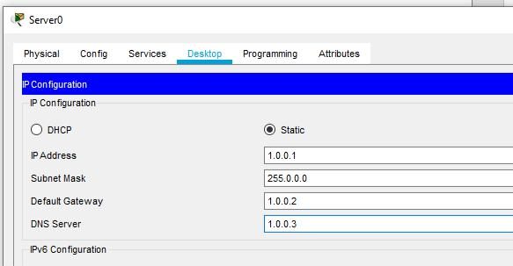

7.) Next click on the Services tab and the DHCP button on the left and enter the following details. Make sure the service button is switched to on Click save when finished.

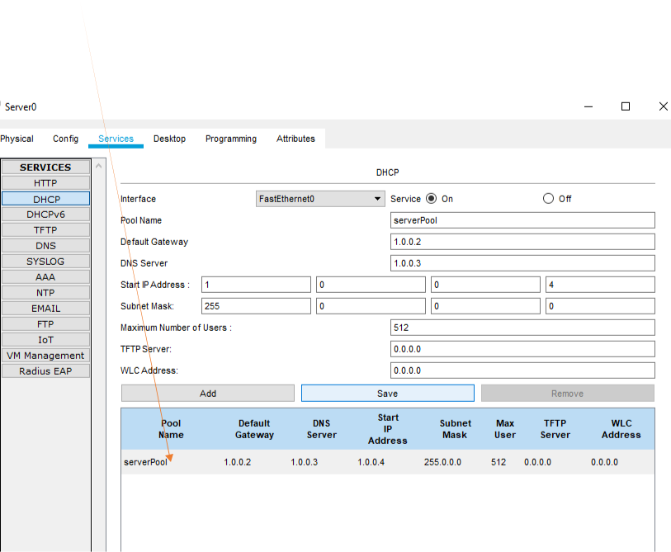

8.) Next click on the DNS button, turn it on and enter the following data below.

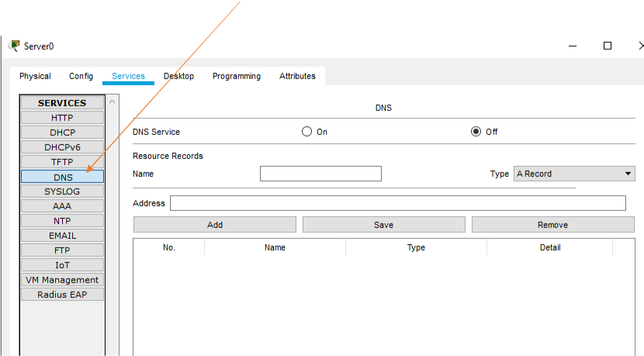

9.) Enter this data and click add.

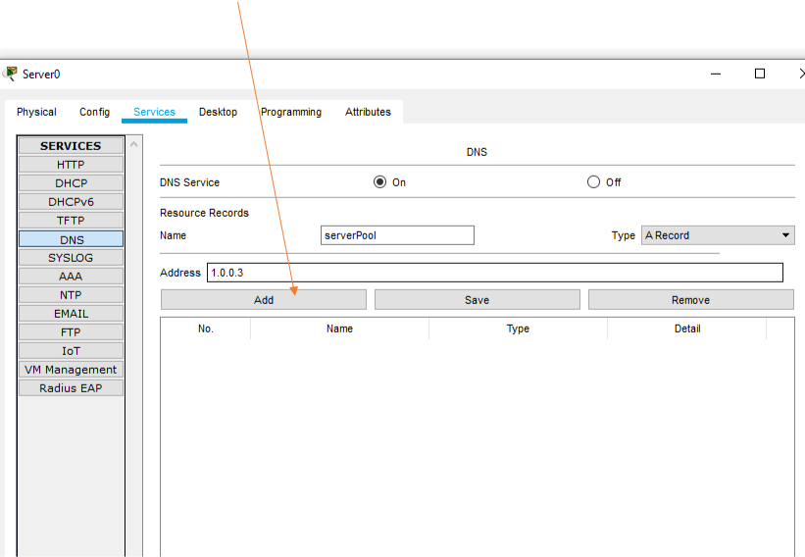

10.) Your screen should look like this.

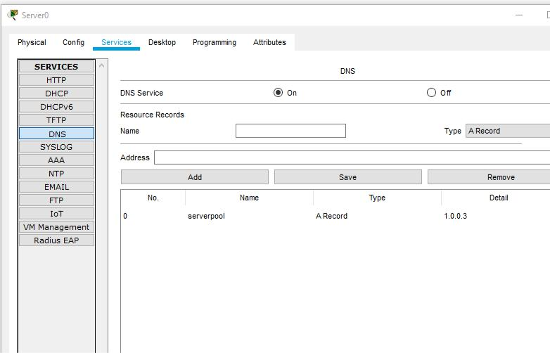

11.) Close everything down click on one of the PCs

12.) Next click on Desktop tab and click on IP Config.

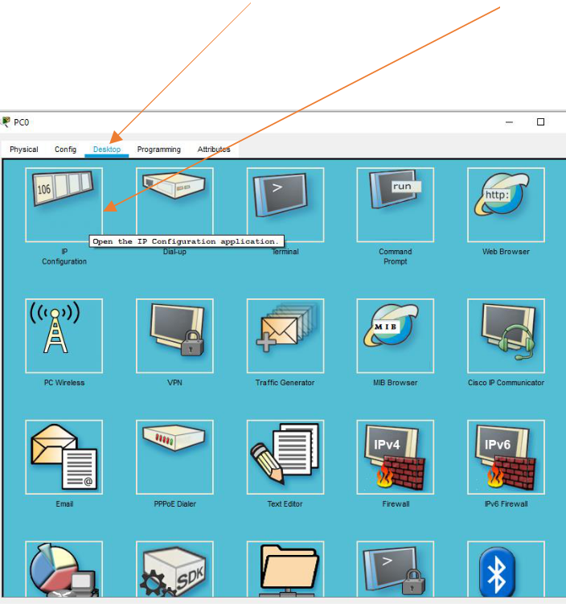

13.) Turn on the DHCP and your request and your PC will connect to the server and the Internet automatically. Your screen should look like this.

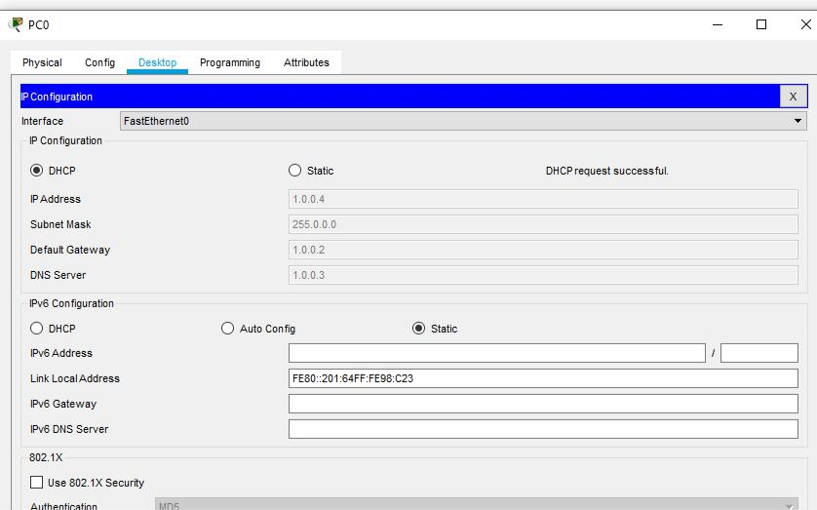

14.) Now send a data packet over the network. Click on the data packet icon once.

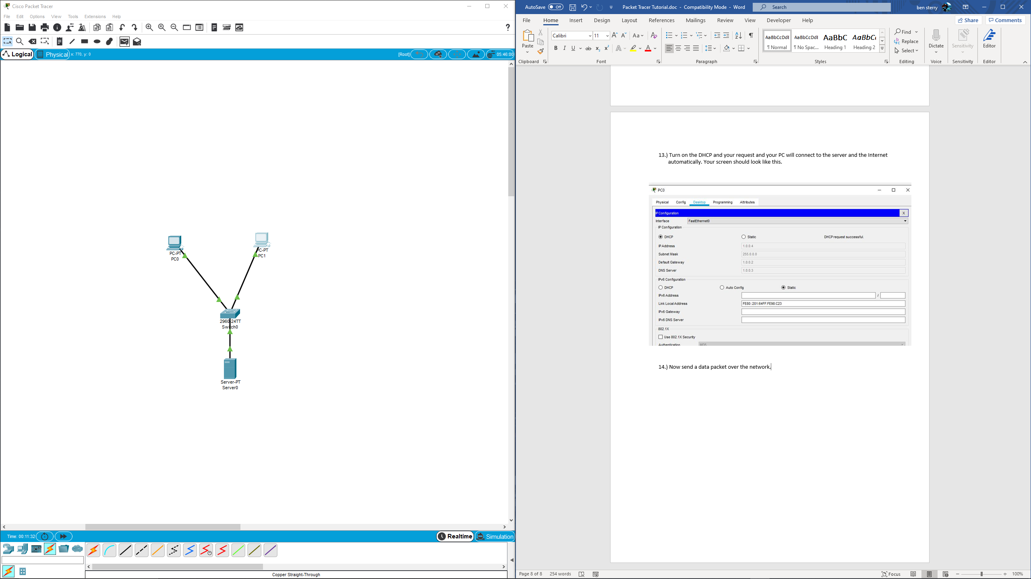

15.) the click on the first pc to add the data packet and then click on the second pc to tell the network where to send it.

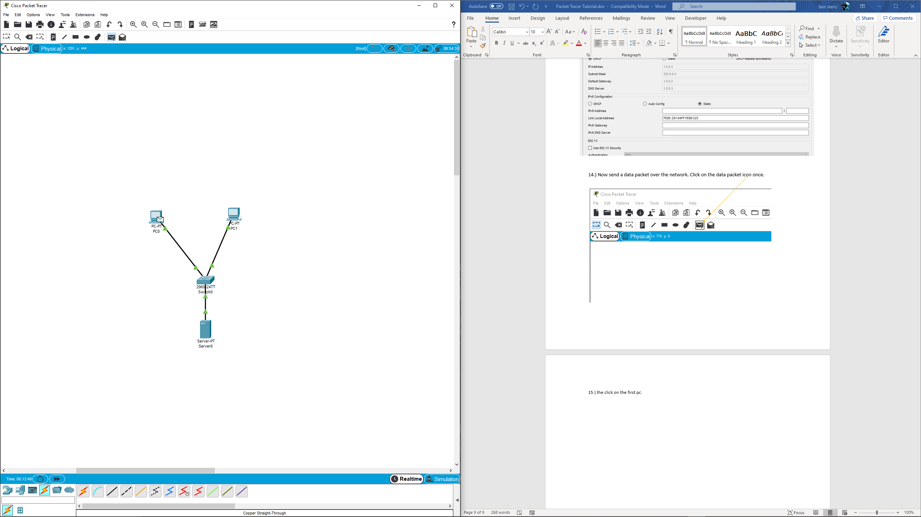

16.) Now click on simulation, and hit the play button to send the dta across the network.

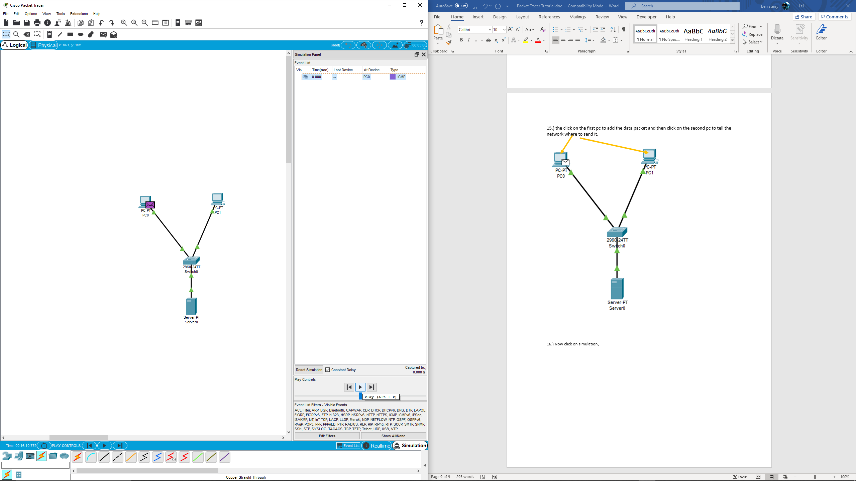

17. The ICMP are the data packets, this could be anything like word documents picyrues etc, the second pass tests the switch ports by sending a dta packet which originates from the switch itself, this should block the data, this is called STP. What is STP? why do you think this secuirty feature exsists?

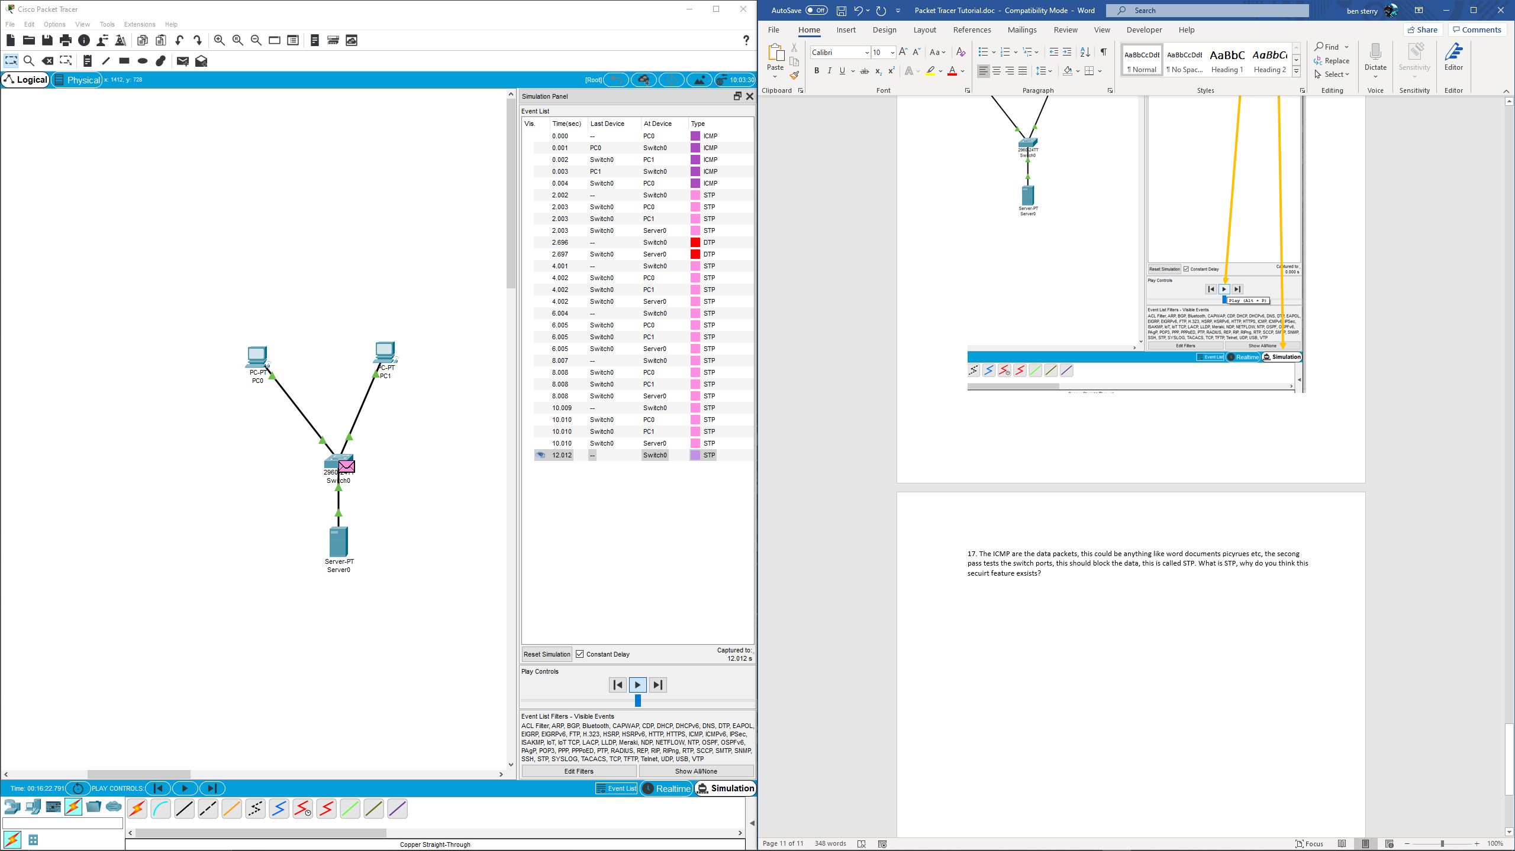

Send your completed works to me @ [Ben.sterry@gloscol.ac.uk](mailto:Ben.sterry@gloscol.ac.uk) between June 30th and August 24th.

**What websites will help me?**

|  |
| --- |
| Asecuritysite.com  Danscourses.com  Hackthebox.eu  Immersive labs  Teach ICT  gflearnfree.org/technology  techipedia.com  Code academy  You Tube  Packet tracer |

**WHAT WILL I STUDY IN MY FIRST YEAR**

|  |
| --- |
| * **Information Technology systems** * **Creating systems to manage information** * **Using social media in business** * **Programming** * **Data modelling** * **Website development** * **IT Project management** * **Cyber security and incidental management** |